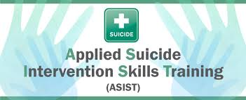

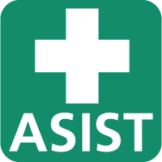
‘Creating Suicide Safer Communities together’

Applied Suicide Intervention Skills Training

Applied Suicide Intervention Skills Training (ASIST) is a two-day interactive workshop in suicide first aid. ASIST teaches participants to recognise when someone may have thoughts of suicide and work with them to create a plan that will support their immediate safety. Although ASIST is widely used by healthcare providers, participants don't need any formal training to attend the workshop - anyone 16 or older can learn and use the ASIST model.
Since its development in 1983 by LivingWorks, ASIST has received regular updates to reflect improvements in knowledge and practice, and over 2,000,000 people have taken the workshop. Studies show that the ASIST method helps reduce suicidal feelings in those at risk and is a cost-effective way to help address the problem of suicide.

“Cutting edge, front-line, hands on, LIFE SAVING resource, made highly accessible and instantly applicable. The kind of training that keeps people alive.”
An ASIST participant

What is ASIST?
An accredited two-day, interactive training that prepares caregivers to provide suicide first aid interventions.

Who can attend ASIST?
Anyone 16 or older (despite previous training) can learn and use the ASIST model. No previous mental health or suicide prevention experience is necessary.

What will you learn as an ASIST trained first aid caregiver?
After taking ASIST, you will be better able to:
- Be suicide alert - identify people who have thoughts of suicide
- Understand the reasons behind thoughts of suicide and the reasons for living
- Access risk and safety - develop a plan to increase the safety of the person at risk of suicide
- Recognise invitations for help
- Recognise potential barriers of seeking help
- Offer support – recognise other important aspects of suicide prevention including life-promotion and self-care
- Effectively apply a suicide intervention model
- Link people with community resources

What are the workshop features?
- Presentations and guidance from two LivingWorks registered trainers
- A scientifically proven intervention model
- Powerful audio-visual learning aids
- Group discussions
- Skills practice and development
- A balance of challenge and safety
- Participant materials include a 20-page workbook, wallet card, and stickers. Participants also receive a certificate upon completing the workshop.

What is the structure of an ASIST workshop?
The ASIST workshop is divided into five sections that follow in a logical progression to gradually build comfort, confidence and understanding around suicide and suicide intervention.
Preparing: Sets the tone, norms, and expectations of the learning experience over the two days.
Connecting: Enables participants to reflect on their own attitudes towards suicide. This creates an understanding of the impact that attitudes can have on the intervention process.
Understanding: An overview of the intervention needs of a person at risk. The trainers focus on providing participants with the knowledge and skills to:
- recognise risk
- develop ‘safe plans’ to reduce the risk of suicide
- increase the safety of the person
Assisting: Presents a model for effective suicide intervention. Participants develop their skills through observation and supervised simulation exercises in large and small groups.
Networking: The trainers share information about resources in the local community and promote participant commitment to encouraging the transformation of local resources into helping networks.

Enquire via Tom or Ann who are both ASIST trained as to when the next training course will run. Or if you would like to run it at your school or ministry and have at least 8 participants, we will arrange with you to come and run a course for you.

Annnichols.ero@gmail.com

Suicide Talk

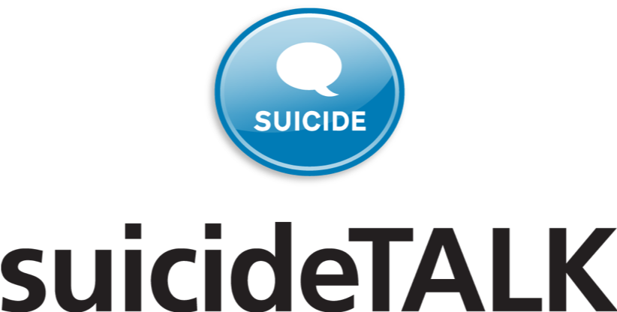

Is a ‘pre-cursor’ to ASIST. It is a 90-minute workshop that can be delivered to large groups.

Suicide talk is about creating a climate of awareness and an interest in learning more about the wide range of suicide prevention activities.
Through discussion and interactive activities, it provides the group with opportunities to explore the most fundamental attitudes towards suicide. It allows clarification of views, explores facts and breaks down barriers that occur around discussing suicide.

Learners end with promises to take steps to create a ‘suicide aware’ community.

It can be delivered to groups of sixth form age students and to staff.

Book directly with Ann or Tom to have ‘suicide talk’ delivered in your school /community.

